EXPERIMENT NO. 9
TOPIC: REPORT ON CLIMATE CHANGE IMPACT AND ADAPTATION IN CHENNAI
1. INTRODUCTION
Chennai, the capital city of Tamil Nadu, lies on the southeast coast of India along the Bay of Bengal. It is one of the fastest-growing metropolitan cities, but it is highly vulnerable to climate change due to its coastal location, dependence on monsoon rainfall, and limited freshwater resources.
2. CLIMATE CHANGE IMPACTS ON CHENNAI
a) Cyclone and Storm Surges
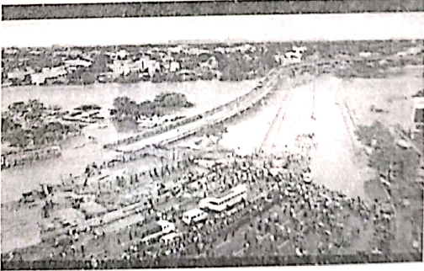
Chennai is frequently hit by cyclones (e.g., Cyclone Vardah in 2016, Cyclone Nivar in 2020), causing large-scale damage.
b) Urban Flooding
The 2015 floods submerged vast parts of the city, displacing millions and causing economic losses of over $20,000 crore.
c) Heatwaves and Urban Heat Island Effect
Rising summer temperatures often cross 42°C, leading to heat stress and health risks.
d) Water Scarcity
The city faces acute water shortages due to changing rainfall patterns, shrinking lakes, and over-extraction of groundwater.
e) Sea Level Rise
The source PDF lists “Rising vector-borne diseases (malaria, dengue) due to stagnant water after floods” under this heading.
3. ADAPTATIONS AND MEASURES
a) Water Management
- Restoration of lakes and tanks to store rainwater.
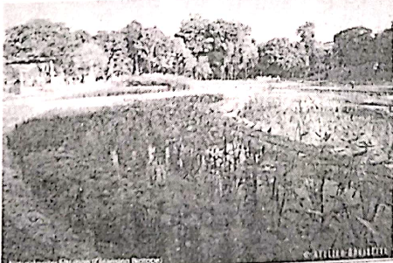
- Promotion of rainwater harvesting in households (made mandatory by the government).
- Desalination plants to ensure drinking water supply.
b) Urban Planning
- Development of flood-resilient infrastructure.
- Creation of storm water drains in flood-prone zones.
c) Ecosystem Protection
- Restoration of wetlands like Pallikaranai Marsh to act as natural flood buffers.
- Coastal mangrove plantation to reduce cyclone impacts.
d) Disaster Preparedness
- Strengthened early warning systems for cyclones and floods.
- Community-based disaster response teams.
4. CHALLENGES
- Rapid urban expansion and encroachment on wetlands.
- Poor solid waste management clogging storm drains.
- Dependence on external water sources during droughts.
- Limited public awareness about climate adaptation practices.
5. CONCLUSION
Chennai faces severe climate-related threats in the form of floods, cyclones, heatwaves, and water scarcity. The city has adopted measures such as rainwater harvesting, desalination, wetland restoration, and disaster preparedness. However, long-term resilience requires stricter urban planning, conservation of natural ecosystems, and community participation in sustainable water and land management.
TERNA ENGINEERING COLLEGE, NERUL
TITLE | REPORT ON CLIMATE CHANGE IMPACT AND ADAPTATION IN CHENNAI
NAME | Avdhut Parish Madhavi
CLASS / BATCH | COMP / SEM III / C2 | ROLL NO. C-60
SIGN

